**BOOKSDEAL SELL AND BUY**

**(WEB APPLICATION)**

**A PROJECT REPORT**

**Under Subject of**

**DESING ENGINEERING – 2B**

***Submitted by***

**Ladva Nikunj (190430116064)**

**Magtarpara Bhavik (190430116067)**

**Moradiya Kartik (190430116077)**

***In partial fulfillment for the award of the degree of***

**BACHELOR OF ENGINEERING**

***In***

**Information Technology**

**Shantilal Shah Engineering College, Bhavnagar**



**Gujarat Technological University, Ahmedabad**

**April 2022**





**SHANTILAL SHAH ENGINEERING COLLEGE**

**Sidsar Campus, P.O. Vartej, Bhavnagar-364060**

**CERTIFICATE**

DATE: 29/04/2022

This is to certified that the project report submitted along with the project entitled **Booksdeal sell and buy** has been carried out by **Nikunj Ladva**(190430116064), **Magtarpara Bhavik**(190430116067), **Kartik Moradiya**(190430116077) under my guidance in partial fulfillment for the degree of Bachelor of Engineering in Information Technology, 6th Semester of Gujarat Technological University, Ahmedabad during the academic year 2021-22.

Prof. C. H. Makwana Dr. M. S. Shah

Internal Guide Head of the Department

(E.C./I.T. Department)

**ACKNOWLEDGEMENT**

We have taken efforts in this project. However, it would not have been possible without the kind of support and help of many individuals and organizations. We would like to extend my sincere thanks to all of them.

We are highly indebted to **Prof. Chintan H. Makwana** for their guidance and constant supervision as well as for providing necessary information regarding the project & also for their support in completing the project. We would like to express my special gratitude and thanks to faculties for giving me such attention and time.

We thanks and appreciations also go to my colleague in developing the project and people who have willingly helped out with their abilities. Every project big or small is successful largely due to the effort of a number of wonderful people who have always given their valuable advice or lent a helping hand.

We sincerely appreciate the inspiration, support and guidance of all those people who have been instrumental in making this project a success. We would also like to thank all the faculty members of I.T. department for their critical advice and guidance without which this project would not have been possible.

Last but not the least We place a deep sense of gratitude to Our family members and Our friends who have been constant source of inspiration during the preparation of this project work.

Name of Student Enrollment No.

Ladva Nikunj 190430116064

Magtarpara Bhavik 190430116067

Moradiya Kartik 190430116077

**ABSTRACT**

*"Booksdeal sell and Buy" is a web base application. Its main objective is to any student easily buy and sell there old or new books with moderate price.*

*BooksDeal is the place where user can buy book openly without worrying about deception. There are two type user can take part and avail free service. the first user is customer and second is admin user For customer user they need to logged in first. if user come for first time then they can be register with email user can see preview of any book from bunch of products cell. in the detail product customer can see related products as per it's choice. they add there product in cart and from cart they can change agglomerate. after affirmation they can disburse using PayPal payment getaway. user can done its payment by PayPal account if have otherwise with it's connected bank card details. after payment they can check its order from history concision. For Admin user they need to verify its account from root admin after scrutiny admin user can add its own categories as per its product and also create products. admin user can check all the order for admin products they can check all the payment history of products and also get address and name of customer for proceedings proceed*

*Now a days big problem for any student is to buying new book or finding old book. Our web provide both service to buying or selling there old book or new book so student efficiently find book for there study. We are Trying to give more feature to user for find book without any types of exception*

**LIST OF FIGURE**

**FIGURE 2.1 AEIOU SUMMARY SHEET ……………………………………………**

**FIGURE 3.1 MIND MAPPING CANVAS……………………………………………….**

**FIGURE 4.1 EMPATHY CANVAS……………………………………………………..**

**FIGURE 5.1 IDEATION CANVAS………………………………………………………**

**FIGURE 6.1 LEARNING NEED MATRIX……………………………………………..**

**FIGURE 7.1 PRODUCT DEVELOPMENT CANVAS………………………………**

**FIGURE 8.1 USE-CASE DIAGRAM…………………………………………………..**

**FIGURE 9.1 DATA FLOW DIAGRAM LEVEL 0…………………………………….**

**FIGURE 9.2. DATA FLOW DIAGRAM LEVEL 1…………………………………….**

**FIGURE 10.1 ADMIN PROTOTYPE……………………………………………………**

**FIGURE 10.2 USER PROTOTYPE……………………………………………………..**

**FIGURE 11.1 REGISTRATION SCREEN…………………………………………**

**FIGURE 11.2 LOG IN SCREEN……………………………………………………**

**FIGURE 11.3 HOME SCREEN……………………………………………………….**

**FIGURE 11.4 PAGE NOT FOUND SCREEN…………………………………………..**

**FIGURE 11.5 BUY BOOK SCREEN…………………………………………………**

**FIGURE 11.6 PAYMENT SCREEN……………………………………………………**

**FIGURE 11.7 CARD EMPTY SCREEN……………………………………………..**

**FIGURE 11.8 BOOKS ORDER SCREEN…………………………………………….**

**FIGURE 11.9 TOTAL BOOKS ORDER ………………………………………………**

**FIGURE 11.10 BOOKS DETAIL FORM………………………………………………**

**FIGURE 11.11 BOOKS CATEGORIES SCREEN……………………………………**

**FIGURE 11.12 BOOKS DETAIL UPDATE…………………………………………**

**TABLE OF CONTENTS**

ACKNOWLEDGEMENT……,,……………………………………………………………...….I

ABSTRACT………………………………………………………………………………...……II

LIST OF FIGURE………………………………………………………………………...……..III

TABLE OF CONTENTS……...………………………………………………………...………IV

1. **INTRODUCTION……...…...……………………………………………………..………….1**
2. **AEIOU SUMMARY…...……………………..………………………....................................2**
3. **MIND MAPPING……...……………………………………...…………………………….5**
4. **EMPATHY MAPPING...…….………………………………...…………………………...8**
5. **IDEATION CANVAS…………………………………………...………………………….11**
6. **LEARNING NEED MATRIX………………………………………….…………….…....13**
7. **PRODUCT DEVELOPMENT CANVAS……………………………….…………….......15**
8. **USE-CASE DIAGRAM…………………………………………………….……………....18**
9. **DATAFLOW DIAGRAM...…………………………………….………………………….20**
10. **PROTOTYPE…………………………………………………………………………........22**
11. **SCREENSHOT……………………………………………………………………………..34**
12. **CONCLUSION…………………………………………………………………………..…24**
13. **REFERENCE……………………………………………………………………….…...….45**
14. **INTRODUCTION**

Our domain name is " Booksdeal sell and buy ".in this application we provide a platform for selling books and also user buy any books in easy way.

We will use new and better technology to speed up our domain. Satisfy everyone's expectations and create a community here for a specific area. because provide to everyone community support for Saving precious time. The environment of our domain will be kept simple. Anyone can sell-buy the book here. In our application buyer can buy old and new books and also if they need to buy xerox copy of any book then it is also possible to buy xerox copy of any books. Buyer also use my favourite option for save book in there profile and buy later. Seller can easily sell there book, for selling his/her book he/she just request to admin for selling there book and then admin upload book details in web application for selling book. Here Admin can manage user data and also manage payment and books order. In our application we are trying to give all feature which can help user to find book from this platform and without any exception user can user this web application.

* **PROJECT SUMMARY**

|  |  |  |
| --- | --- | --- |
| **Project Title** | Booksdeal Sell And Buy | |
| **Aim** | Our main aim is to any student easily buy and sell there old or new books with moderate price. | |
| **Project Category** | Web base application | |
| **Tools** | IDE | Visual Studio Code |
| Language/Frameworks | Reactjs, CSS, JavaScript, Nodejs |
| Database | MongoDB |

**2. AEIOU SUMMARY**

AEIOU is an investigative tool to help interpret observations gathered by ethnographic practices in the field. It is an Observation tool. Its two primary functions are to code data, and to develop building blocks of models that will ultimately address the objectives and issues of a client. AEIOU is an investigative tool to help interpret observations gathered by ethnographic practices in the field. It is an Observation tool. Its two primary functions are to code data, and to develop building blocks of models that will ultimately address the objectives and issues of a client.

**The AEIOU summary canvas contains 5 Sections:**

1. Activity
2. Environment
3. Interaction
4. Object
5. User
6. **Activities:**

It describes the activities that are taking place on the site: -

1. Buy

2. Sell

3. Donet

4. Rent

5. Exchange

6. Payment

1. **Environment:**

Following are the environment in which our project can easily run:

1. Collage

2. House keeper

3. Industry

4. Book store

5. Library

1. **Interaction:**

It describes the communication between people and who interact with whom:

1.Interaction among Student to student

2.Interaction among Library to student

3.Interaction among Book store to user

4.Interaction among User to book owner

5.Interaction among User to administrator

1. **Objects:**

It describes which objects were present and used on the site: -

1. Books

2. Books list

3. Phone number

4. Books photo

1. **Users:**

It specifies the users who are related to the project:

1. Student

2. Professor

3. Doctor

4. Engineer

5. Book Salesman

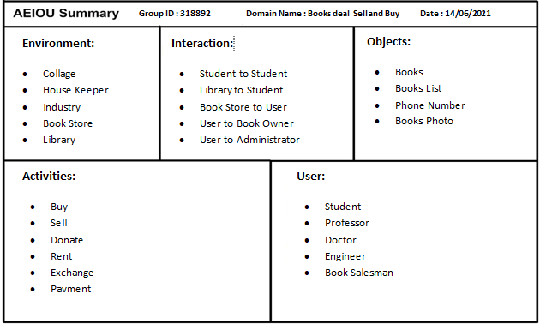

*FIGURE 2.1 AEIOU SUMMARY SHEET*

**3. MIND MAPPING CANVAS**

Mind mapping are used to organized information, topic or points in form of diagrams, drawing, or other form like hierarchically. Mind map crated single concept of topic of project in the center of the blank page or canvas. Other thing related to the topic or the project are connected by different branches. Through the mind map canvas, the information related to the project to be clear and is being easy for understanding of the project domain.

**Mind mapping canvas contains 6 Sections:**

1. User
2. Buy And Sell
3. Search
4. Categories
5. My Favourites
6. Details
7. Places

**1) User:**

1. Student
2. Professor
3. Doctor
4. Engineer
5. Book Salesman

**2) Buy and sell:**

1. Old book
2. New book
3. Donate book
4. Xerox book

**3)Search:**

1. Author
2. Book title
3. Book publication

**4) Category:**

1. English
2. Engineer
3. Science
4. Agriculture
5. Spiritual

**5) My favourite:**

1. Book list

**6) Details:**

1. Phone number
2. Email id

**7) Place:**

1. Collage
2. Library
3. Book store
4. Industry
5. House keeper

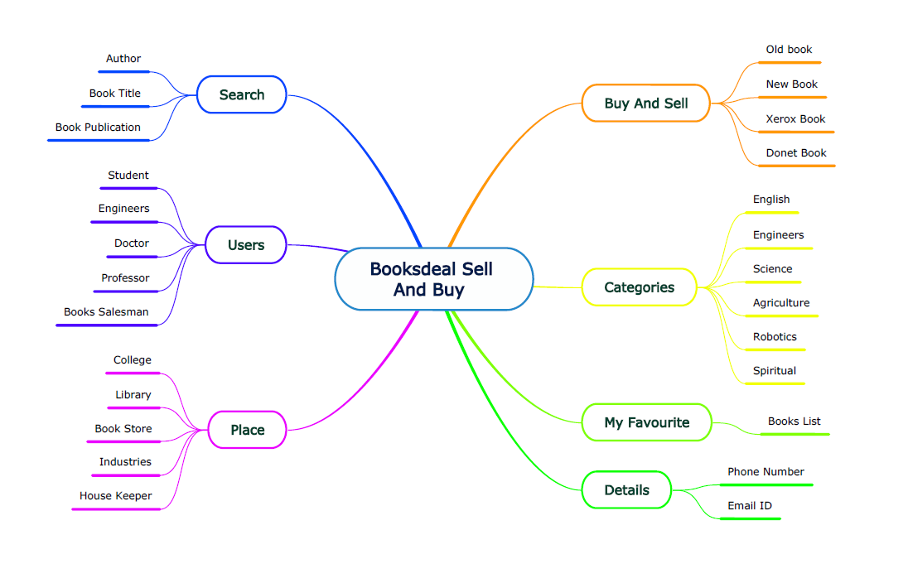

*FIGURE 3.1 MIND MAPPING CANVAS*

**4. EMPATHY CANVAS**

In this canvas, you have to find out user to your problem and stakeholders, different activity, broad stories of their activities.

**Empathy canvas contains 4 Sections:**

1. Users
2. The Stack holders
3. Activity
4. Happy Stories and Sad Stories
5. **Users**

It specifies the users who are related to the project:

1. Student

2. Doctor

3. Professor

4. Engineers

5. House keeper

6. Citizen

**2)Stack Holders**

It specifies the people who are directly or indirectly related to the project:

1. Seller

2. Buyer

3. Donator

4. Librarian

5. Student

**3)Activity:**

Following are the various activities that are to be carried out in the project:

1. Buy

2. Sell

3. Donet

4. Rent

5. Exchange

6. Payment

**4)Story Boarding**

❖**Happy Stories**:

➢ Pushpak is a clever and poor student so that he can not purchase book . Bhavy will donate his book using our application and Pushpak does show this message and he does contact with bhavy and he buy a book without any money.

➢ Ram is searching mechanical book in his area but he has not buy book in his area he is searching mechanical book using our application and he saw Shyam's book and he contact with shyam. so ram is buy book using our application. So, Ram is happy.

Here, Mahesh and Rajesh feel happy

❖**Sad Stories**:

➢ Pratham had purchase rent book in his area's library using our application but he does not submit Rent book before deadline date so he had pay extra fine for rent book. So, Pratham is sad.

➢ Sahil see mechanical book in our application but kenil was saw mechanical book before Sahil's seen but he was not sure to purchase book. so Sahil will purchase book from our application.

So, Kenil is sad because of his late division.



*FIGURE 4.1 EMPATHY CANVAS*

**5. IDEATION CANVAS**

These are the 3rd step of the project or problem. From the user canvas, you have an idea what are the people? Also which type of the activities is related to your project and people? Situation and location regarding to your activity? And after possible solution?

In this canvas we also get the idea of the props to be used.

**The Ideation canvas contains 4 Sections:**

1. People
2. Activity
3. Situation
4. Props
5. **People**

1. Student

2. Doctor

3. Professor

4. Engineer

5. House keeper

6. Citizen

1. **Activity**

1. Buy

2. Sell

3. Donate

4. Rent

5. Exchange

6. Payment

1. **Situation/Location/Context**

1. Collage

2. Library

3. Hostel

4. Industry

5. House keeper

6. Exam time

**4)Props**

• When user select buy book from our application but it is so difficult to search seller. So our application give location of seller. So he find early and buy books as soon as fast.

• When student take rend book from our application. our application send message to submit your rent book before deadline date.



*FIGURE 5.1 IDEATION CANVAS*

**6. LEARNING NEED MATRIX**

Learning need Matrix Sheet is the last canvas Sheet of Design Engineering Subject .

First of all LNM canvas full form is Learning Needs Matrix Canvas will help the student to identify the learning requirement at an early stage along with prioritization/time allocation for each learning priority

**The Learning need matrix contains 4 sections:**

1. Tools/Methods/Theories
2. Applicable Standards and design
3. Software/Situation/Skill
4. Component material
5. **Tools/Methods/Theories**
6. Rest API
7. Pricing Suring
8. Maps Creation
9. JSON-Web-Token
10. Security & Verification
11. **Applicable Standards and design**
12. Testing Security of Web APK
13. Follow Web protocols
14. Design of web application
15. Flow of application
16. **Software/Situation/Skill**
17. VS code
18. JSX CSS
19. Java Script
20. React js,Nodejs and MongoDB
21. Images Upload System
22. Website to kern techniques and Algorithm
23. **Component material**
24. Servers
25. Chrome development tool
26. Web Testing
27. Laptop for developing
28. Web Responsive Application

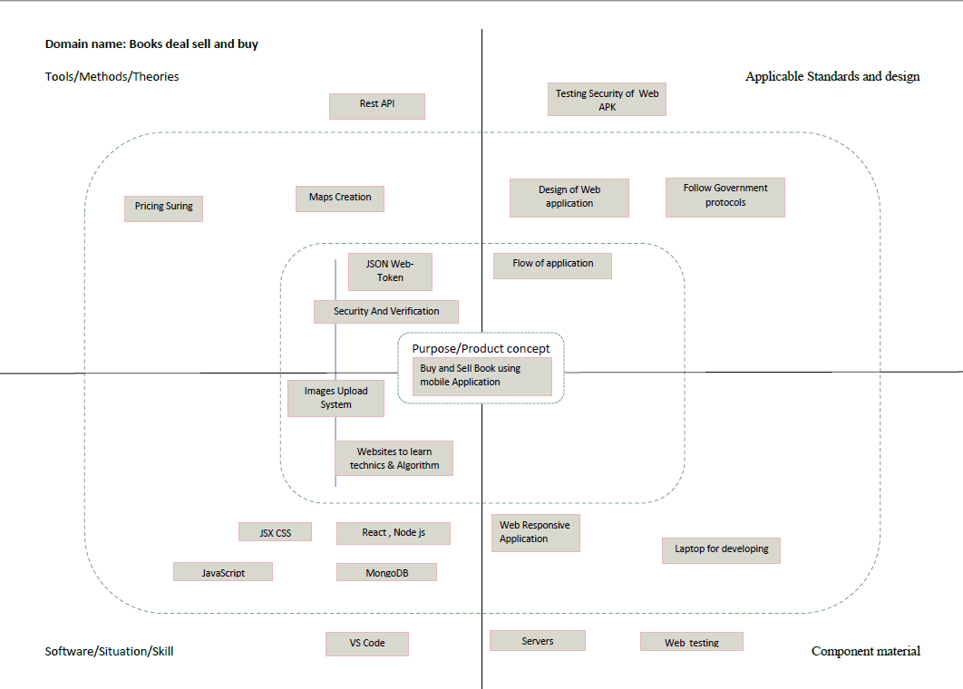

*FIGURE 6.1 LEARNING NEED MATRIX*

**7. PRODUCT DEVELOPMENT CANVAS**

Product development is the 4th step in design Engineering . From possible solutions, you have idea about what product is and how do we develop it?

From this canvas we get Product experience, product features, components, Customer revalidation and suggestions for redesign.

**The Product Development canvas contains 8 Sections:**

1. Purpose
2. People
3. Product Experience
4. Product Function
5. Product Features
6. Components
7. Customer Re validation
8. Reject, Redesign, Retain
9. **Purpose**
10. Helping student
11. Easy buy and sell book
12. Useful for poor student
13. **People**
14. Student
15. Doctor
16. Professor
17. Engineers
18. House keeper
19. Citizen
20. **Product Experience**
21. It feel happy for fast buy old book
22. Useful for student
23. **Product Function**
24. Communicate using chat and call
25. Share Location
26. Categories option for search book easily
27. **Product Features**
28. Mobile
29. Call and chat
30. Internet
31. Old book
32. **Components**
33. Buy and sell old book
34. **Customer Re validation**
35. Easy to buy book
36. Donet book
37. **Reject, Redesign, Retain**
38. Rent book deadline notification
39. When book deadline come send message



*FIGURE 7.1 PRODUCT DEVELOPMENT CANVAS*

**8. USE-CASE DIAGRAM**

Use cases specify the expected behaviour (what), and not the exact method of making it happen (how). A key concept of use case modelling is that it helps us design a system from the end user's perspective. It is an effective technique for communicating system behaviour in the user's terms by specifying all externally visible system behaviour.

A use case diagram is usually simple. It does not show the detail of the use cases:

• It only summarizes some of the relationships between use cases, actors, and systems.

• It does not show the order in which steps are performed to achieve the goals of each use case.

1. **Admin**
2. Verify Account
3. Help and support
4. **Buyer**
5. Log in
6. Search
7. Buy Book
8. Help and Support
9. Communication
10. **Seller**
11. Log in
12. Sell book
13. Communication
14. Help and Support

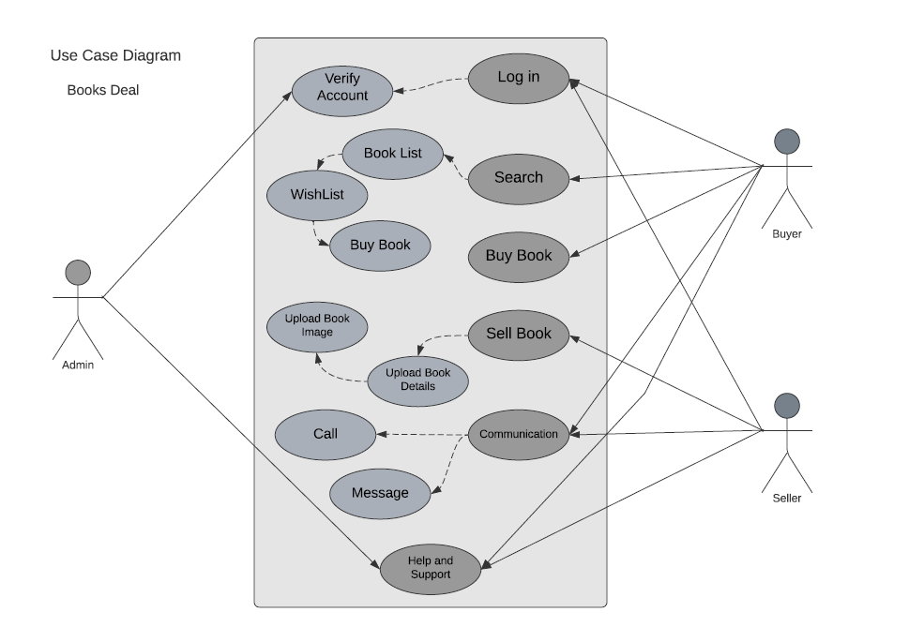

*FIGURE 8.1 USE-CASE DIAGRAM*

**9. DATA FLOW DIAGRAM**

**Level 0 :**

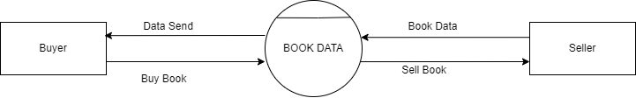

*FIGURE 9.1 DATA FLOW DIAGRAM LEVEL 0*

**Level 1 :**

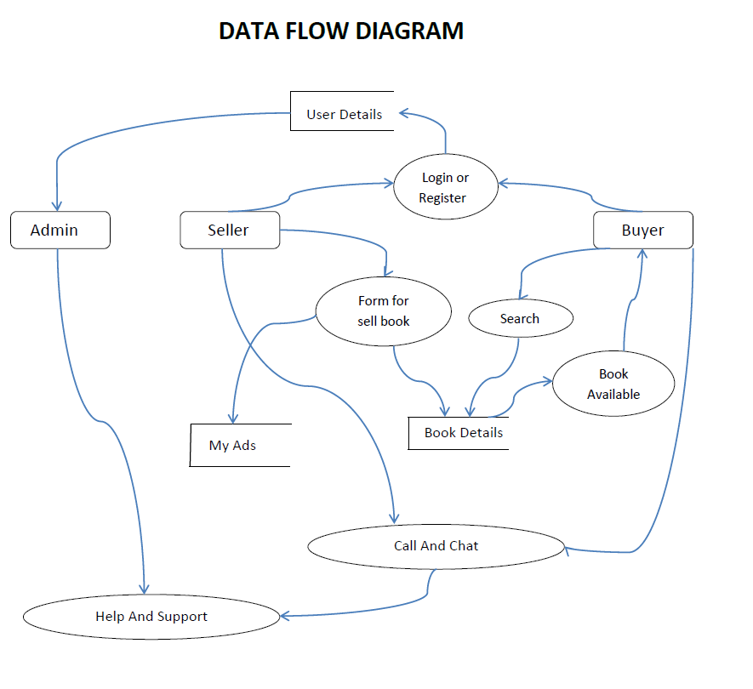

*FIGURE 9.2 DATA FLOW DIAGRAM LEVEL 1*

1. **Database**
2. User Details
3. My Ads
4. Book Details
5. **Attributes**
6. Admin
7. Buyer
8. Seller
9. **Features**
10. Login or Register
11. Add Book
12. Book List
13. Help And Support

**10. PROTOTYPE**

A prototype is an initial creation of a product that shows the basics of what a product will look like, what the product will do, and how the product operates. A prototype isn't meant to be the final version; it's the rough draft form of the product. It'll often have elements that demonstrate how the product will work, even though the prototype may not have the functionality that the final product will have after it's professionally manufactured. The prototype helps you to get a solid idea of what the product will be and make alterations while the item is still in concept mode.

Follow Two User Interface

1. Admin
2. Customer

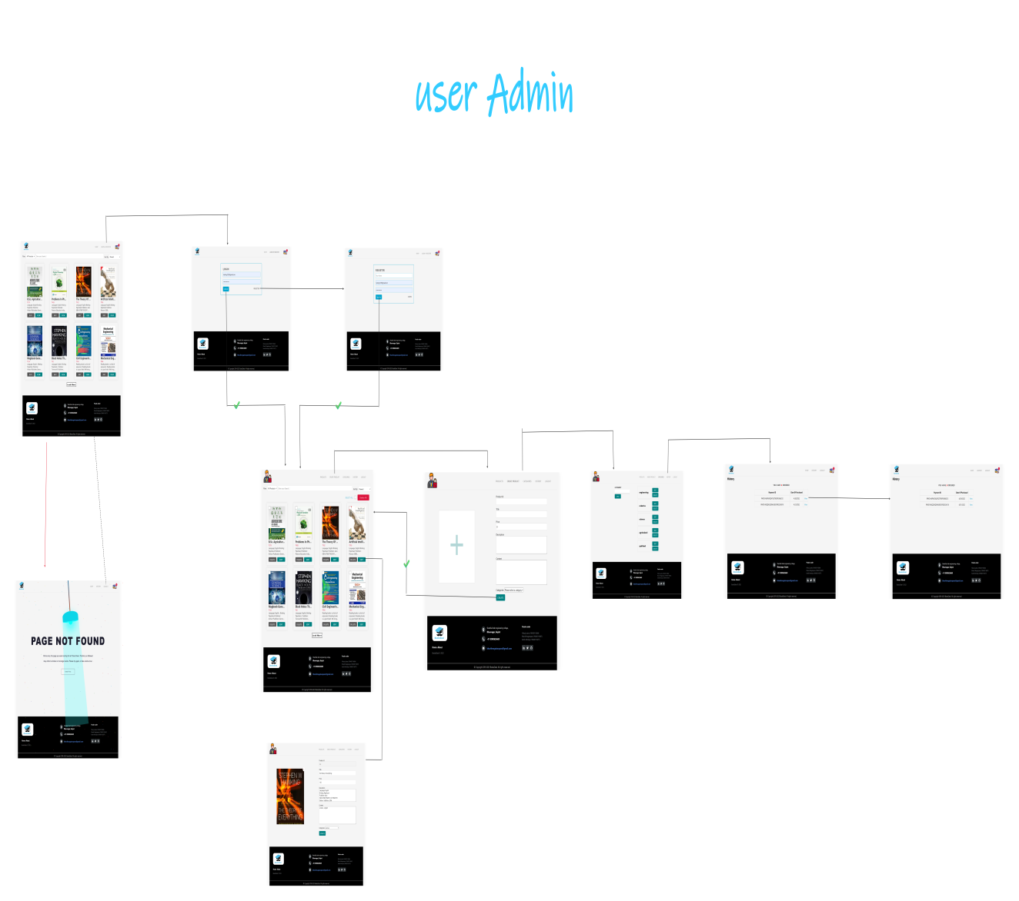

*FIGURE 10.1 ADMIN PROTOTYPE*

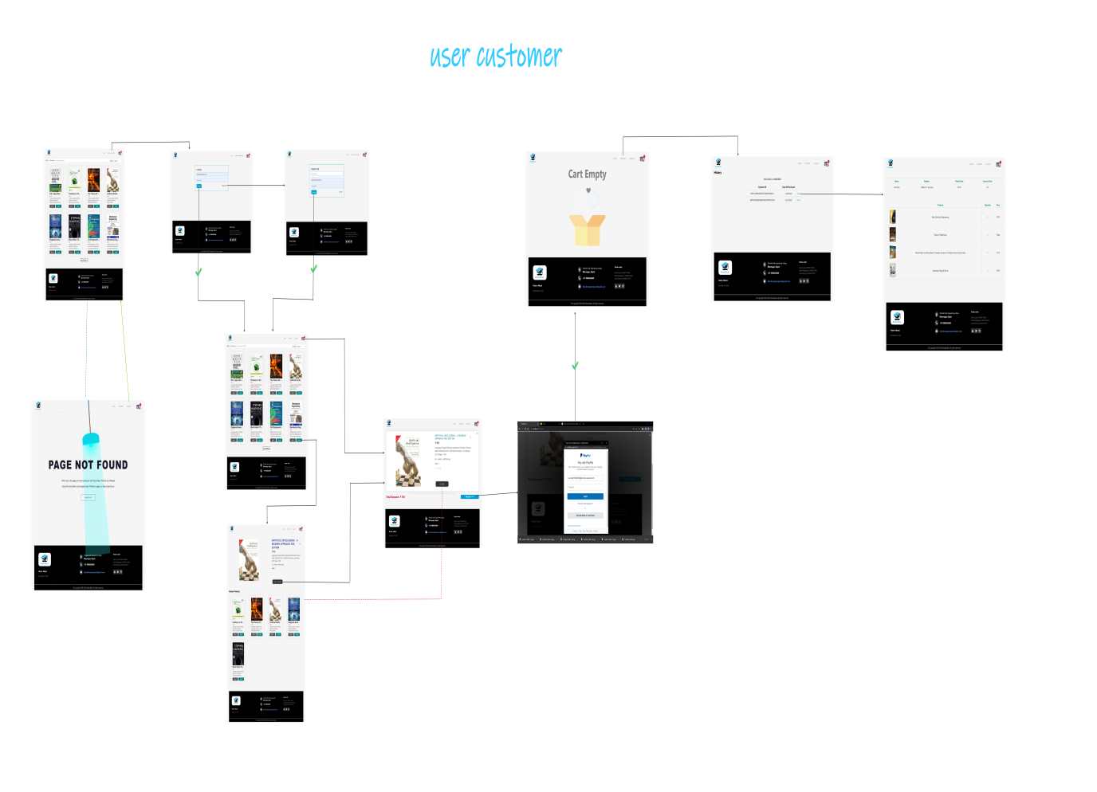

*FIGURE 10.2 USER PROTOTYPE*

**11. SCREENSHOT**

1. Registration form that lets website users to get registered with the web site and get access to applicable facility, service and product.

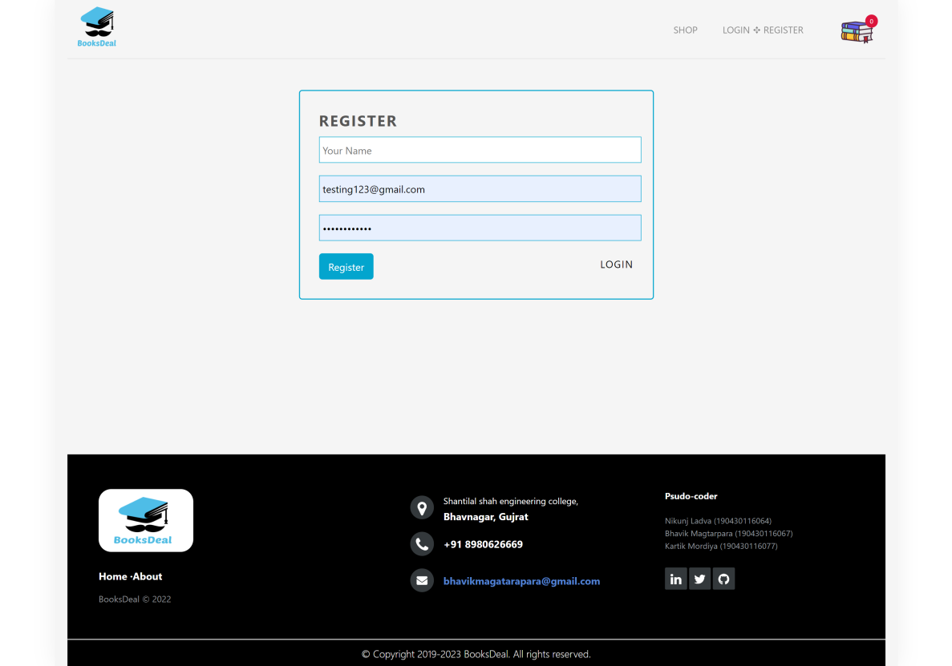

*FIGURE 11.1 REGISTRATION SCREEN*

2. After register user can log in and access service and product.

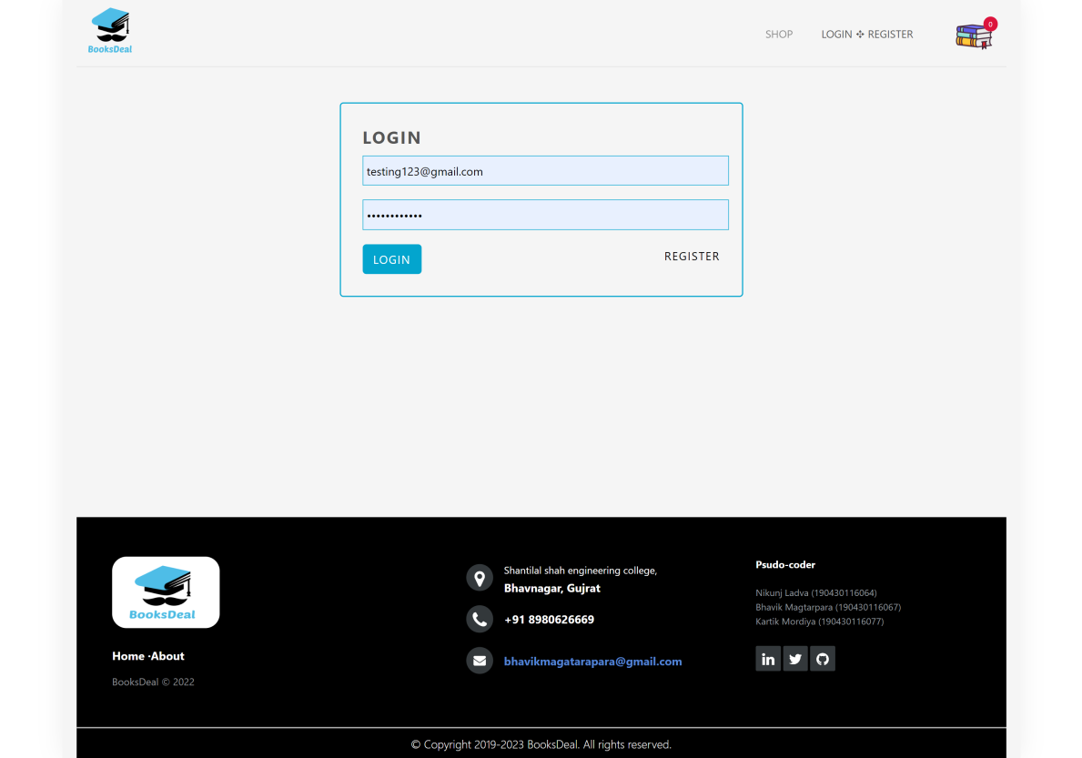

*FIGURE 11.2 LOG IN SCREEN*

1. After log in user redirect to home screen and access web application service.

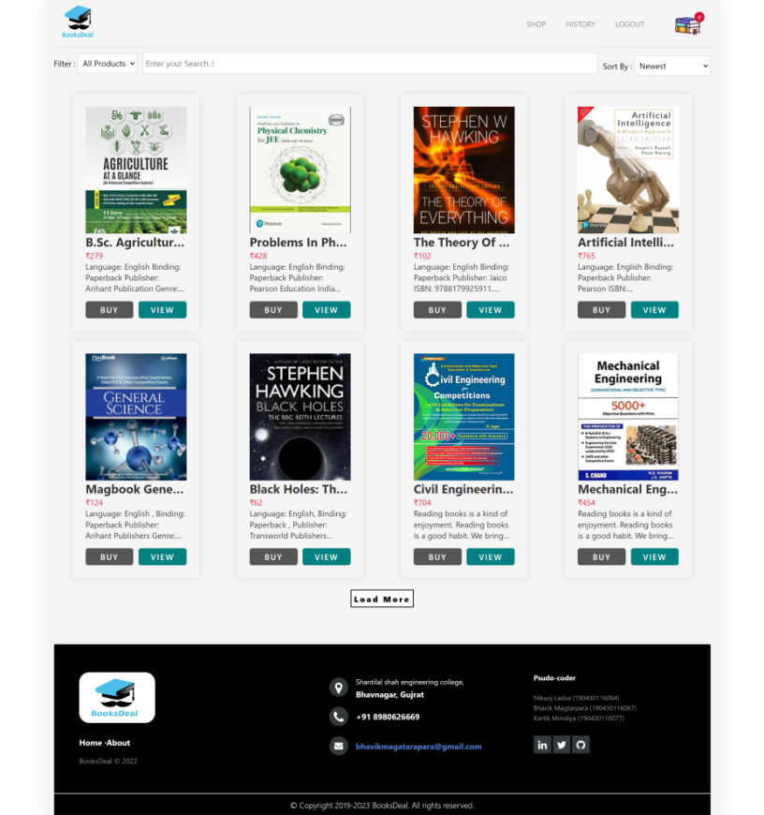

*FIGURE 11.3 HOME SCREEN*

1. If user search invalid page then he/she redirect to page not found screen.

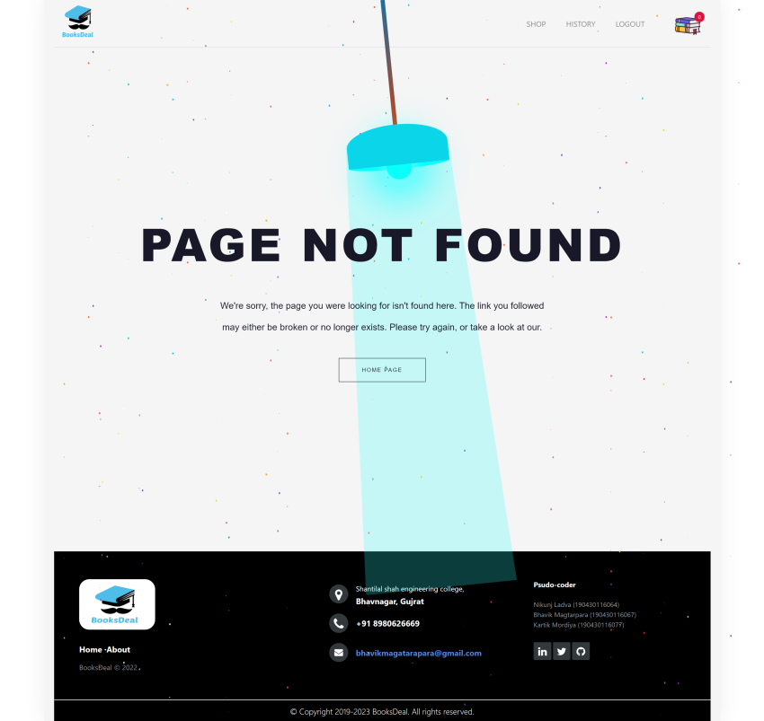

*FIGURE 11.4 PAGE NOT FOUND SCREEN*

1. User can buy book from this screen.

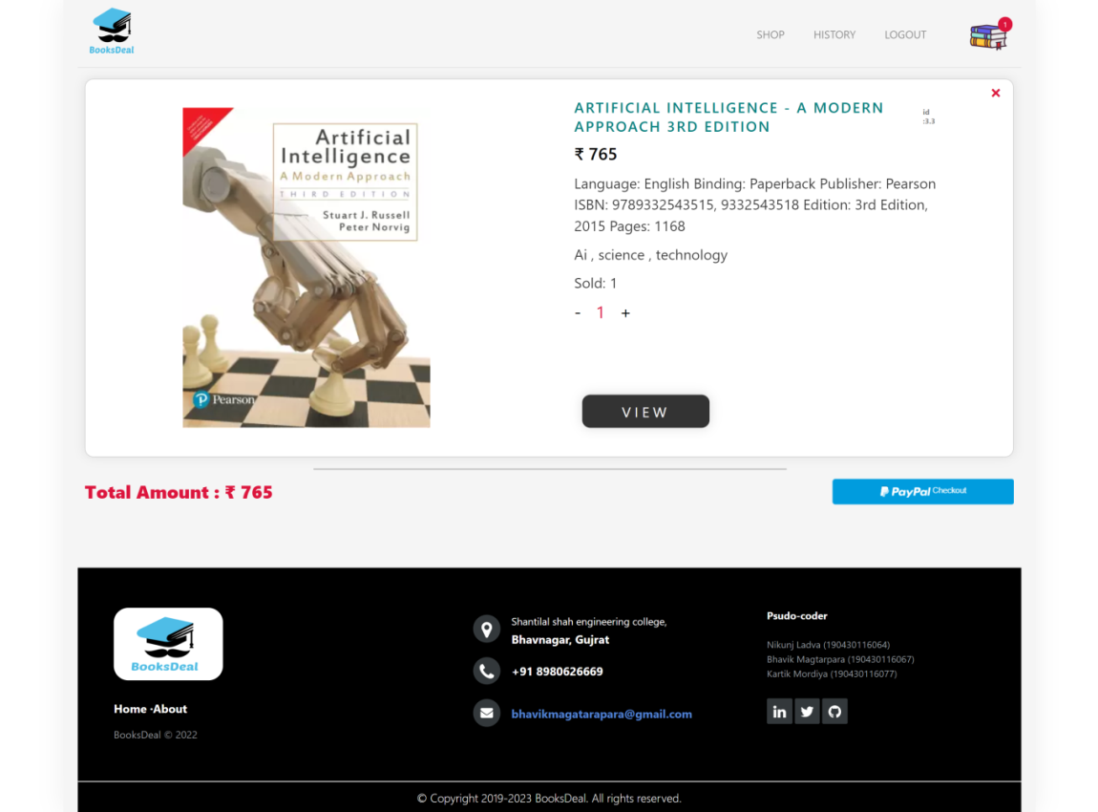

*FIGURE 11.5 BUY BOOK SCREEN*

1. After buy book he/she going to payment process.

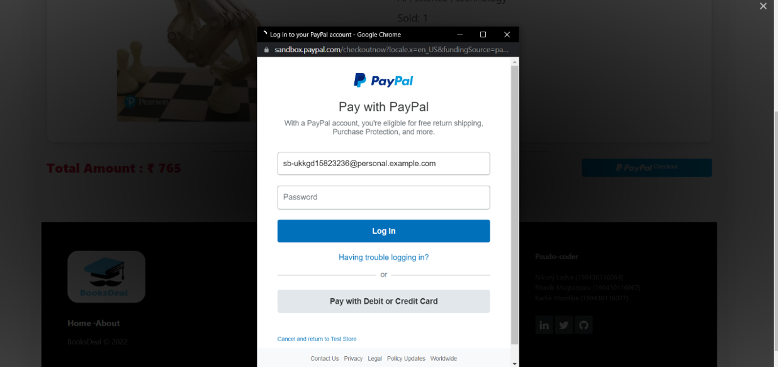

*FIGURE 11.6 PAYMENT SCREEN*

1. In this can user see there added card

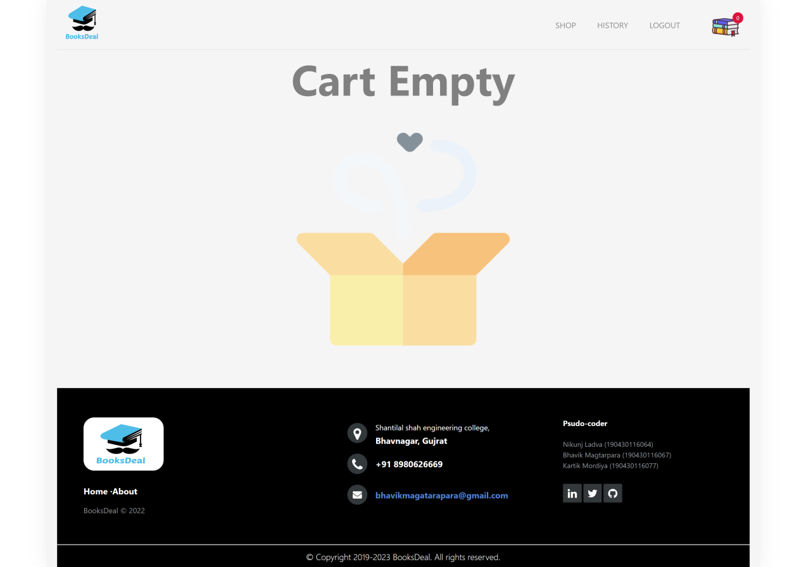

*FIGURE 11.7 CARD EMPTY SCREEN*

1. In this screen user see there order history

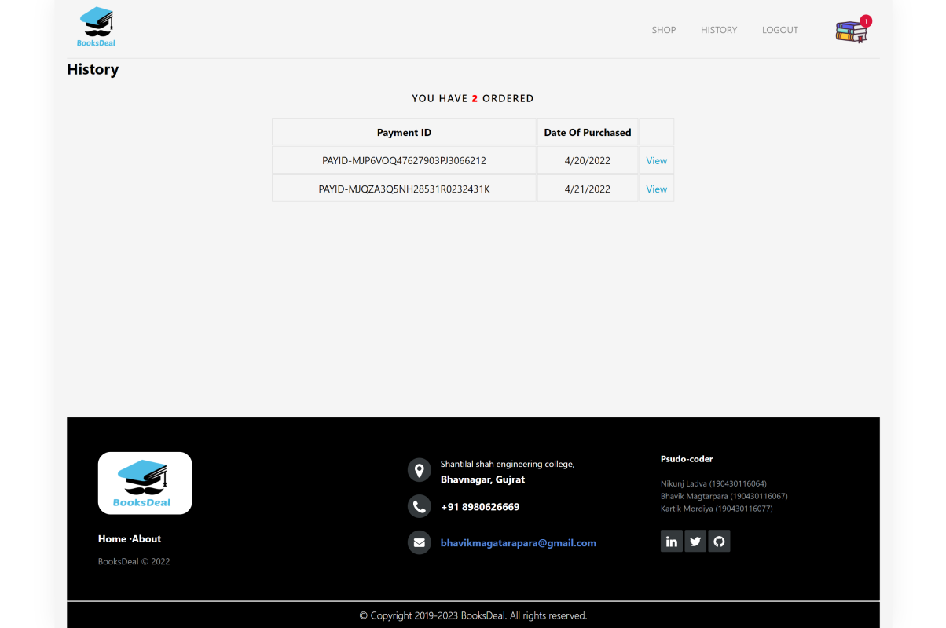

*FIGURE 11.8 BOOKS ORDER SCREEN*

1. In this screen user can access there all book ordered history*.*

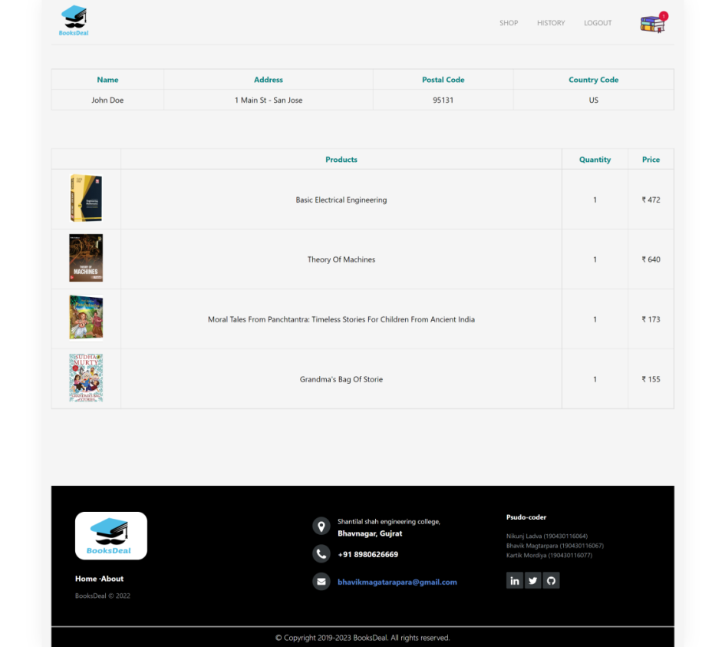

*FIGURE 11.9 TOTAL BOOKS ORDER*

1. For selling book, details of book should be fill in this form.

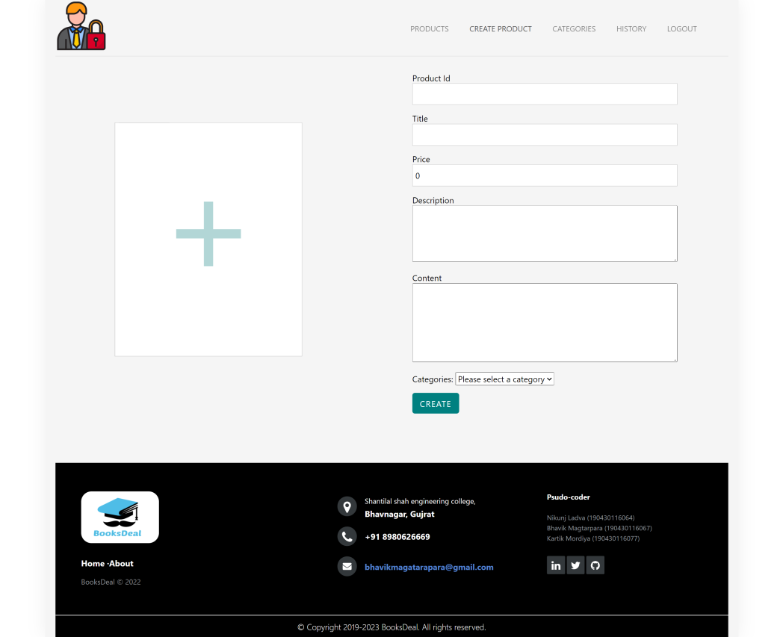

*FIGURE 11.10 BOOKS DETAIL FORM*

1. After fill book details form he/she can select this book is which categories.

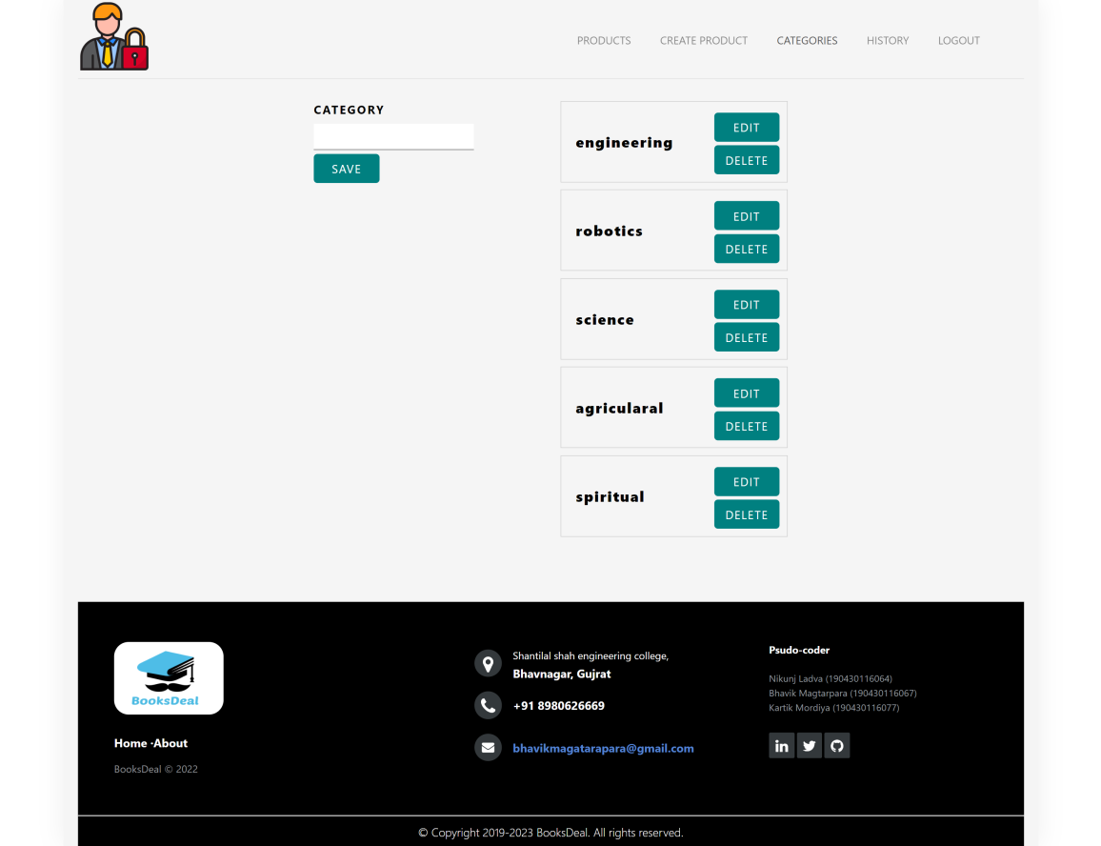

*FIGURE 11.11 BOOKS CATEGORIES SCREEN*

12.For changing any book details he/she redirect to update book detail screen.

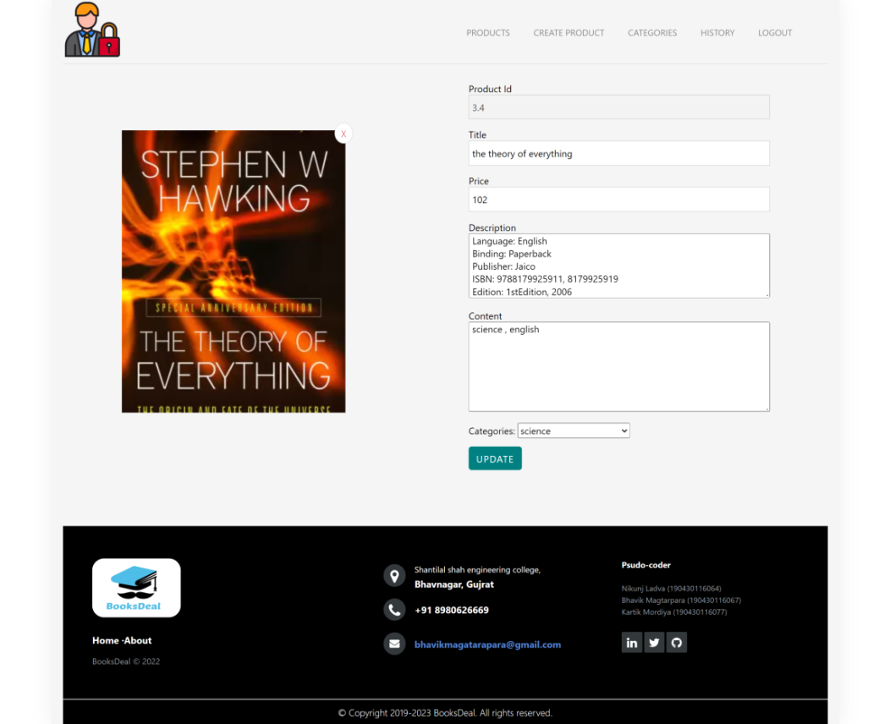

*FIGURE 11.12 BOOKS DETAIL UPDATE*

**12. CONCLUSION**

The booksdeal is tech solution to make easy life of booklovers. yes this is absolutely free for all without taking any middleware charge. for making easiness for user to buy any books for there reading habits they can be wait or they buy a books from this middle options. the main objective of the service is to find the client for the seller to make them profitable and place more categories user friendly ui can attract user to come one more time again and again.

Books Deal is the leading Bookstore with the best discount and fast shipping. Books Deal is one of the fastest ways to buy books online at comfortable prices. We provide all types of Academic, Competitive and General Books. Books Deal is the best Online bookstore for book lovers. All types of books available from our great bookstore. If you want to buy books online, Books Deal is the right choice for you. It is the best source to purchase books online.

If you read, you can succeed. Be smart by reading a good book and Feast your eyes on a good book. Each book you read always gives full of inspiration. Love reading and get new ideas. If you can’t Read, you can’t improve your knowledge.

**13. REFERANCE**

1. **CANVAS REFERANCE**

* [**https://www.youtube.com/watch?v=EHnLvkDG06M**](https://www.youtube.com/watch?v=EHnLvkDG06M)
* [**https://www.youtube.com/watch?v=JbACpEho-D0**](https://www.youtube.com/watch?v=JbACpEho-D0)
* [**https://www.youtube.com/watch?v=yw-jl_oZDy8**](https://www.youtube.com/watch?v=yw-jl_oZDy8)

1. **DESIGN ENGINEERING GUIDLINE**

* [**https://de.gtu.ac.in/ViewCircular**](https://de.gtu.ac.in/ViewCircular)

1. **NODEJS DOCUMENTATION**

* [**https://nodejs.dev/learn/the-nodejs**](https://nodejs.dev/learn/the-nodejs)
* [**https://www.w3schools.com/nodejs/nodejs_uploadfiles.asp**](https://www.w3schools.com/nodejs/nodejs_uploadfiles.asp)
* [**https://www.w3schools.com/nodejs/nodejs_mongodb_find.asp**](https://www.w3schools.com/nodejs/nodejs_mongodb_find.asp)

1. **POSTMAN API DOCUMENTATION**

* [**https://www.postman.com/Workspace**](https://www.postman.com/Workspace)

1. **NODEJS NPM PACKAGE DEPENTENCIES**

* [**https://www.npmjs.com/package/express**](https://www.npmjs.com/package/express)
* [**https://www.npmjs.com/search?q=nodemoon**](https://www.npmjs.com/search?q=nodemoon)

1. **MONGODB DOCUMENTATION**

* [**https://www.mongodb.com/docs/guides/?_ga=2.247104260.18817763.1650801653-18221092.1649142470**](https://www.mongodb.com/docs/guides/?_ga=2.247104260.18817763.1650801653-18221092.1649142470)
* [**https://www.mongodb.com/docs/manual/crud**](https://www.mongodb.com/docs/manual/crud)
* [**https://www.mongodb.com/docs/manual/tutorial/query-embedded-documents**](https://www.mongodb.com/docs/manual/tutorial/query-embedded-documents)